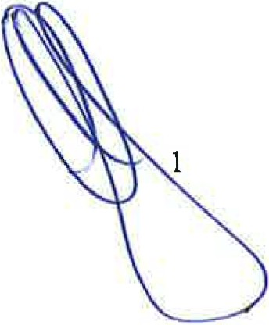

CLIENT- INFORMATION SHEET

No. | In accordance with Articles two (2) through five (5) of the Due Diligence Convention and the Federal Marketing Commission Circular of December 1998, concerning the prevention of money laundering, the following information may be supplied to banks  And /or other Federal Institutions for Purposes of verification.
1 | Date: | Wednesday, 4TH JUNE 2025
2 | Client Name | WILLIAM JOHN FINK
3 | Citizenship | SOUTH AFRICA
4 | Passport Number | M00409767
5 | Passport Issue Country I Expiration Date | SOUTH AFRICA /23 APRIL 2033
6 | Federal ID Number | 5904085011086
7 | Date of Birth | 08 APRIL 1 959
8 | Email Address | william@gcomholdings.com
9 | Address / Telephone | 229 HULL ROAD, RYNFIELD BENONI, GAUTENG  T:+27 79670 9422: +971 55624 5002
10 | Business Name | G COM HOLDINGS NETWORK CONSULTANCIES EST.
11 | Business Address | NANDIDEV CONSULTING
12 | Registered Office | Cl-F1 SF 0443 AJMAN FREE ZONE AJMAN
13 | Registration Number | 1099740
14 | Business Fax Number | N/A
15 | Business Phone Number | +27 79 670 9422: +0971 55624 5002
16 | Email Address | william@gcomholdings.com
17 | BANK NAME | FAB Bank
18 | Branch and Branch Address | FAB Al Jaddaf Building. P.O. Box 52053 Dubai-UAE
19 | Bank Officer's Name | Mr. Saikishore Rao
20 | Telephone Number(s) | +971 4 565 8438
21 | Fax Number | N/A
22 | Bank Officer Email | Saikishore.Ghantasala@bankfab.com
23 | Account Name | G COM HOLDINGS NETWORK CONSULTANCIES EST.
24 | Account Signatory Name | Mr. WILLIAM JOHN FINK
25 | Account Numbers  IBAN NUMBER: AE540351001326847224001 | AED: 1001326847224001  EURO: 1001326847224002  USD: 1001326847224003
26 | SWIFT CODE | NBADAEAA
27 | . Earnings Fund from | TRADE PLATFORM
28 | Are funds free and clear? | YES
29 | Accountant | BIBHU PRASAD SAMANTA
30 | Accountants Details | Bibhu Prasad Samanta, Associate Chartered Accountant from England and Wales  Office Address: Cl -1F -SF0443, Ajman Free Zone, Ajman,Contact details: 0567718652

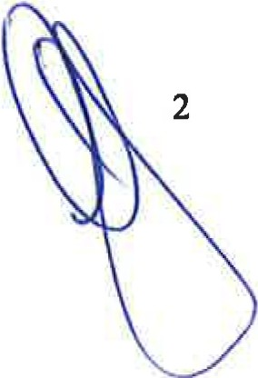

Declaration:
I hereby swear under penalty of perjury, that I AM AND CERTAIN BOARD MEMBERS ARE THE SIGNATORIES of the account and that the funds/asset for Bank Guarantee. The information provided herein is accurate and true. All monies engaged in this transaction are derived from non ­ criminal origin; and, are good, clean and cleared. The origins of funds are in compliance with Anti ­ Money-Laundering Policies as set forth by the Financial Action task Force (FATF) 6/01.
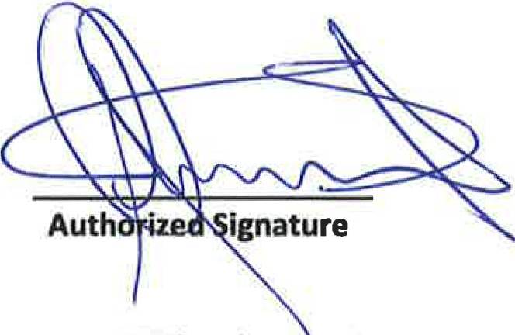

DATE: 4th June 4, 2025 Name: WILLIAM JOHN FINK
Title: MR
Passport Number: M00409767 Country of Issue: SOUTH AFRICA Issue Date: 24 APRIL 2023
Expiry Date: 23 APRIL 2033

APPENDIX 1: DIRECTOR/SIGNATORY PASSPORT

APPENDI X 2: COMPANY REGISTRATI ON CERTIFICATE

y--!.l
••••,.......... (.. ;:ii,-... 1



()&ti !>.l>-'t·S «< ..
..'"II.....



4--
;
Professional license

1-;.-., · ·- .:... .. ....::..... ·} ...-..- .,.. .._-;;. :1-.·
L I

, ...,. b.-. 

:o c:· !:: -·- ... .




.•l l.,_ ' \ :.-..•.r.!£:1 :-v-"
•a:.. -=.. ...\ \•}• . t.4.F.z:·· t
-_,.

: "\ !'. :r rocg
::ci..n·:,

"." "1r1. "s: 3:o·s co·,,,_, ..l':.'"';

,.........1 10

, .lj . .D I .I
Tt-E MIU.Tt<;

- 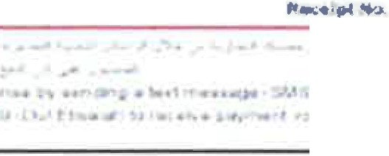• i

.. • I' ...
t... .- :. ·. .,.- :--" ,,,.. .• A......;..;,. _ .. -"" -·r -- .!..;....a >...,. ,. 1 .,;; .-; ,; ;;J . ,. ... -;,. • . • ' · 1 •_.,,;_, ;-.., J,;._1
.
'


4

CIS FORM Rev.1.0 - CICC Council of International Chambers of Commerce



APPENDIX 3: COMPANY INCORPORATION CERTIFICATE

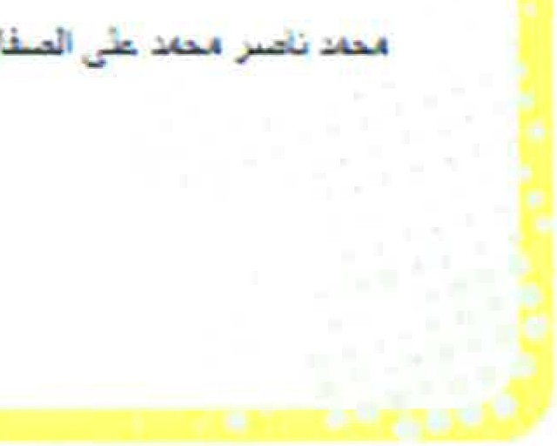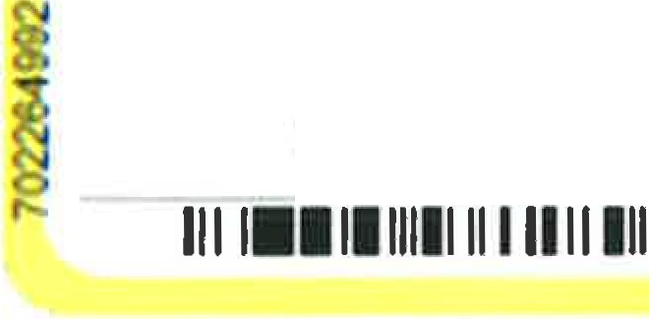
-_--__-.... .,,......._. ·-·•._.....,..
m :
G
-1n199s
. .
:
0 c
ULT
E-> E
e)A J,...,
3 9-16 :. ...,. &J:.
.....vJ •) ).•
2.'1.'87'd533

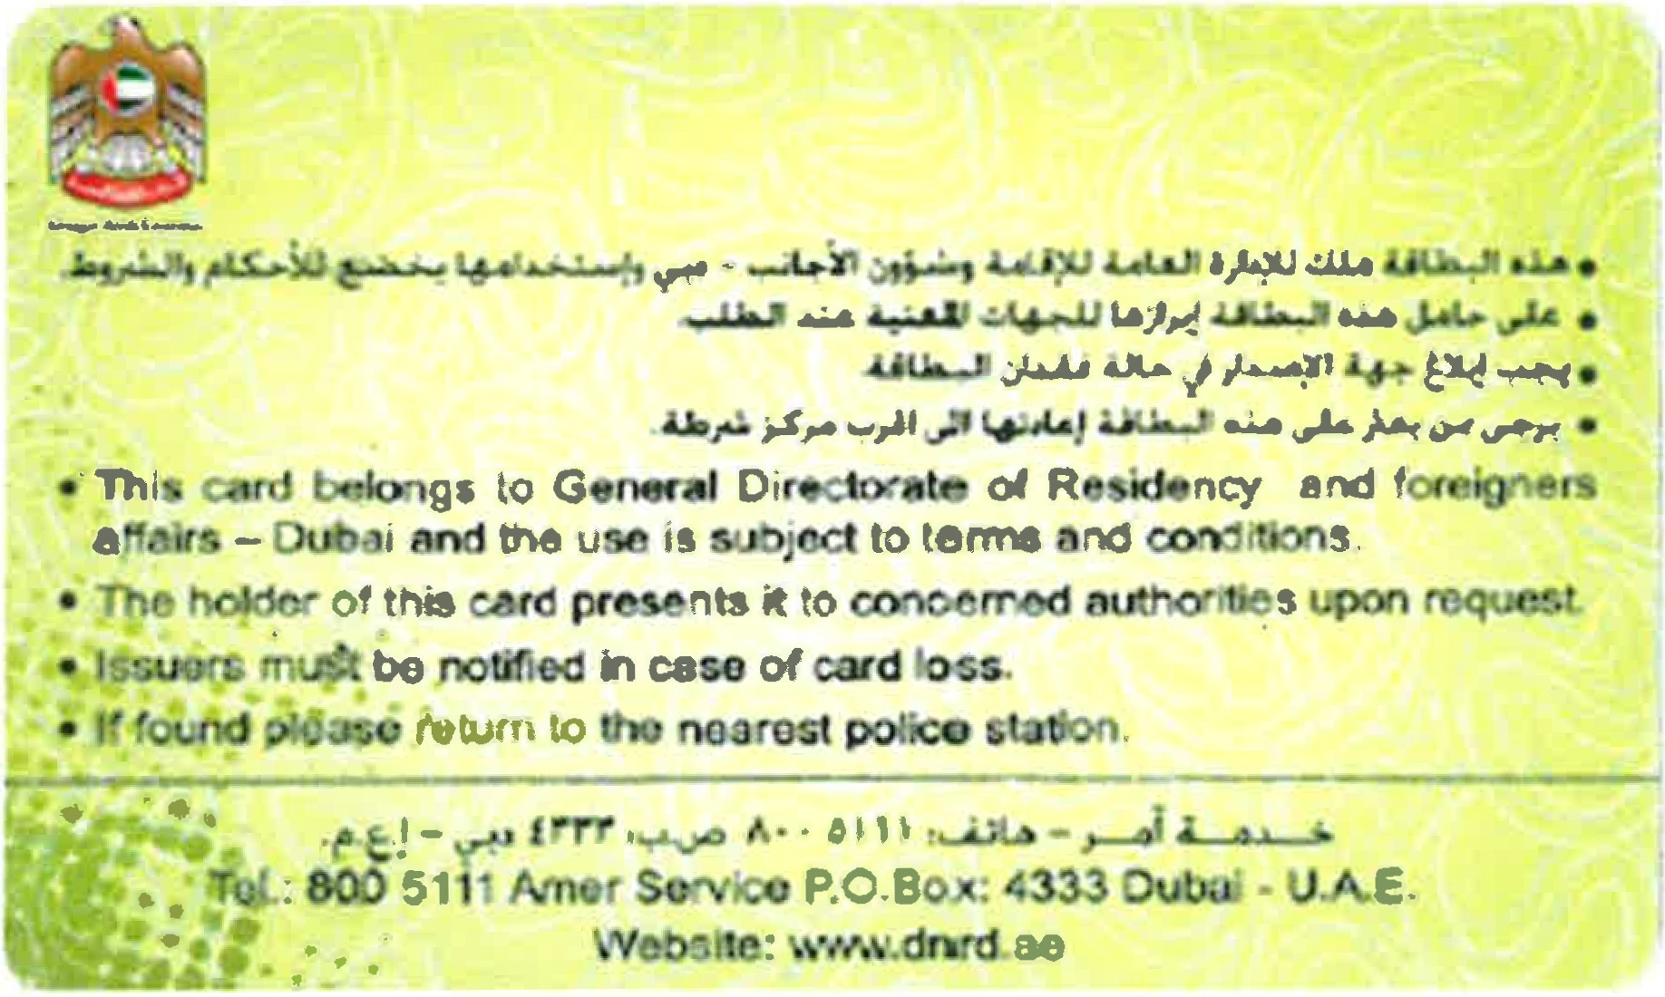

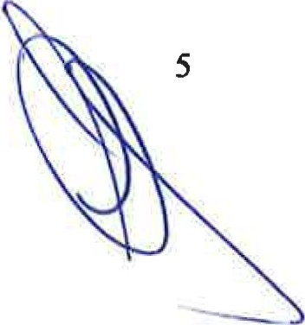CJS FORM Rev.1.0 - CICC Council of International Chambers of Commerce

